**Online Study Company**

***OSS* = Online study site**

**“The roots of online education are bitter, but the fruit is sweet”**

**Our Github Repo Link:**

[**https://github.com/iuthub/ip-group-project-team-004.git**](https://github.com/iuthub/ip-group-project-team-004.git)

**Visit this URL in order to see our web site:**

<http://stepup.uz/>

**Team members:**

1.Khaydarov Mirrakhmon (U1810180)

2.Karimov Otabek (U1810062)

3.Kuchkarov Utkirbek (U1810142)

4.Siddikov Khalillokhon (U1810162)

5.Tursunov Shokhrukh (U1810175)

**Brief Information about our site (company) and its business activities.**

Firstly, our site provides students, teachers some online company workers to take surveys online. For example, this site helps teachers to keep students active and together in such kind of situations and surveys, they will not escape from this survey if they have a good internet connection.

Secondly, our site can be used to replace the google surveys or social network surveys and make a concurrence between them. Due to fact that our site is from (.uz) it can be free for all users that have a tas-ix internet or mobile data.

Thirdly, our site provides a different test conditions that can be provided by professors that are using our site or just students or workers can access these tests and make a better sense of their IQ.

Furthermore, students from various universities or colleges can access the test that are created by other (strange) professors from different sources (universities). These tests can be public and also private.

All tests will be given by users and each test will be controlled and checked either it is proper created or not by admins and system. All information are free and open sourced.

**Why we choose this business activity?**

Because we were already in quarantine when this project were given to us, consequently some of us do not have a good internet connection to global network and our local recourses are not such good as we expect. That`s why we choose this online testing system and created this site for students and professors. They will communicate with help of our site with each other and do some activities and check tests instead of using google services, which are not depends on tas-ix, so it consumes a lot of net traffic, while our site is not because of included tas-ix.

**Future expectations:**

We are going to attract more professors, students, stuffs and other job workers to populate our company (site). We will organize groups that are able to keep a number of people active in a one group.

Add new functionality that can add some video lessons, full study programs and some lecture notes.

In the future, we will open our own organization like google classroom, youtube and others. May be in the future we will be a good concurrent for them also.

**Main Page of our website and it is implementation**

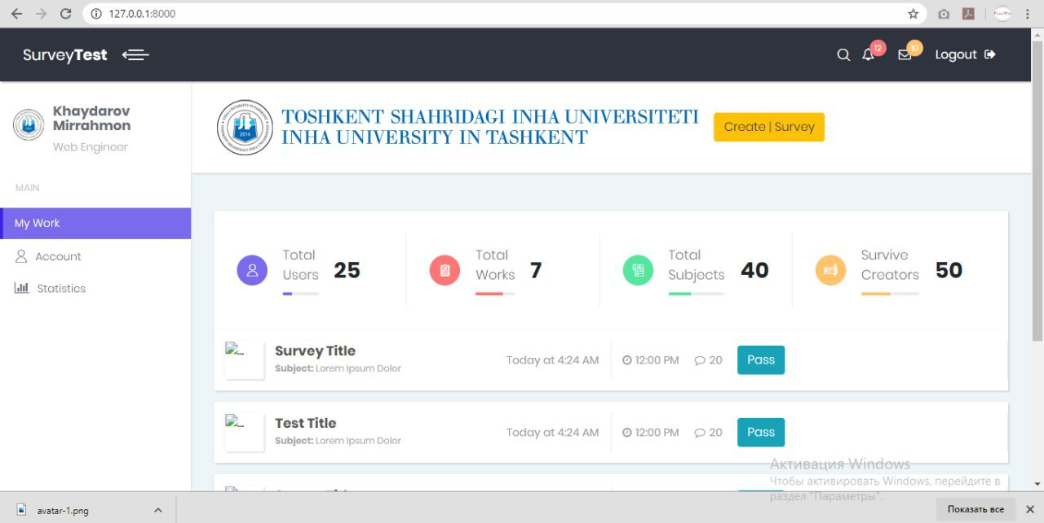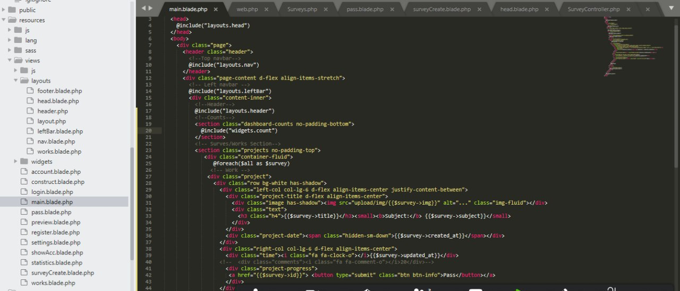

So our main page and some codes are illustrated here.

**SurveyTest page:**

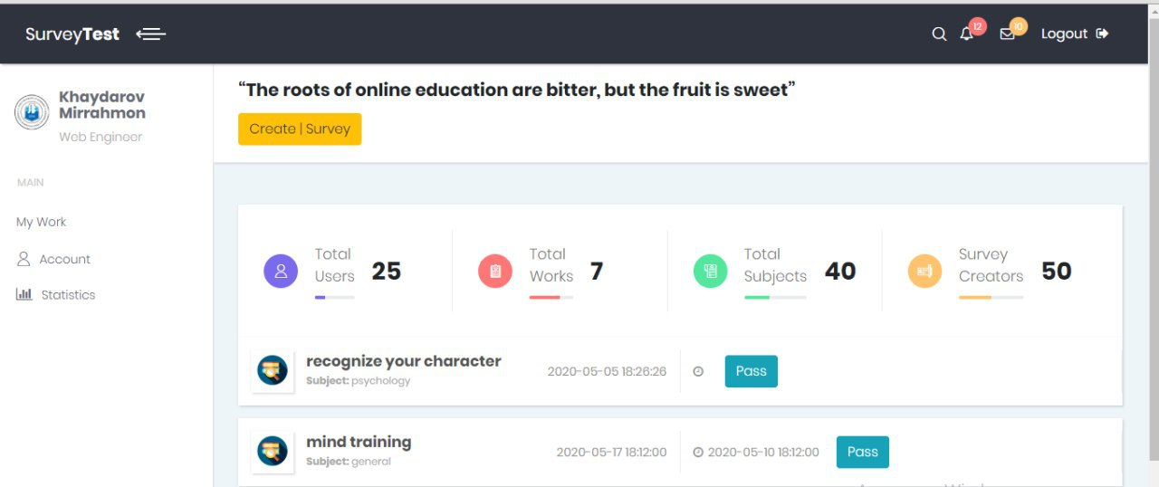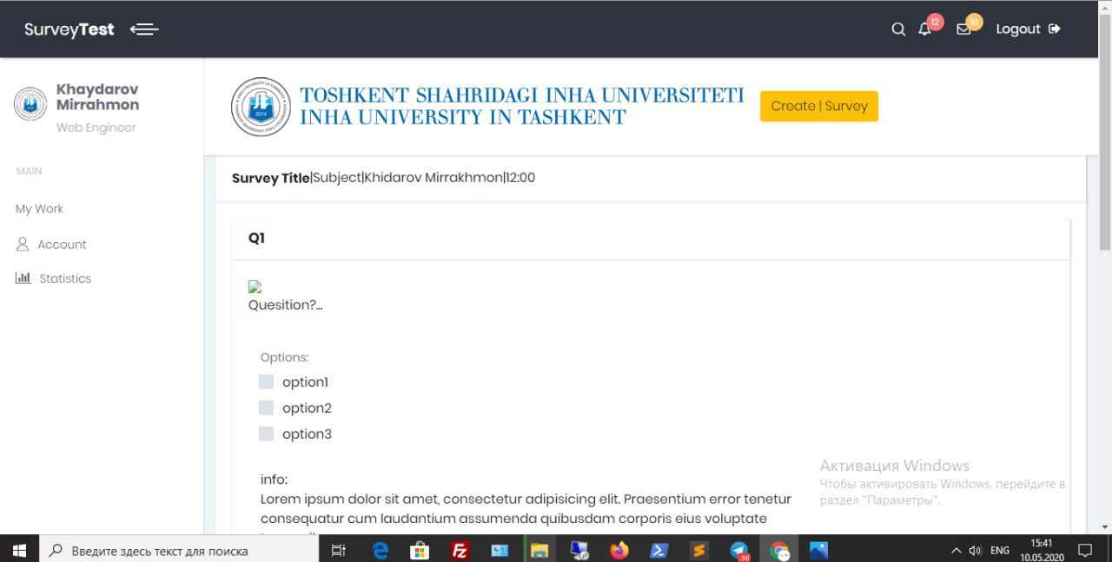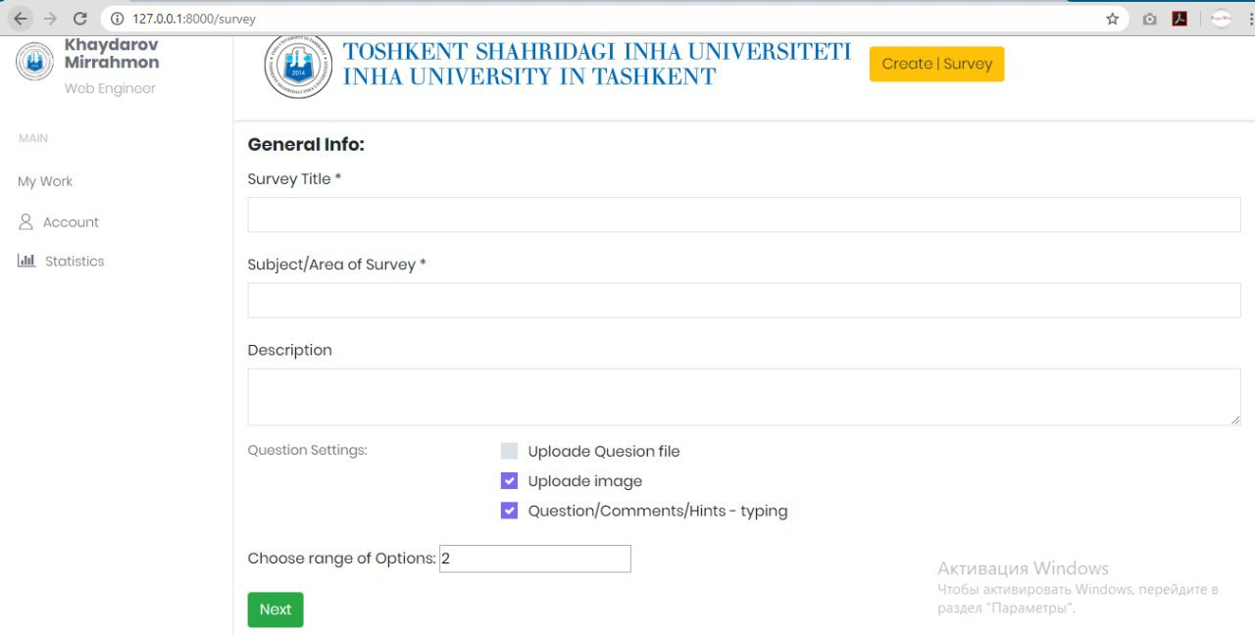

**Here the page of SurveyTest and it is design.**

**Control and Models:**

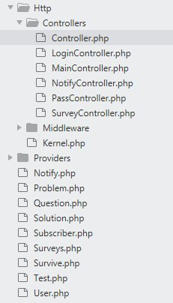

**Here the construct:**

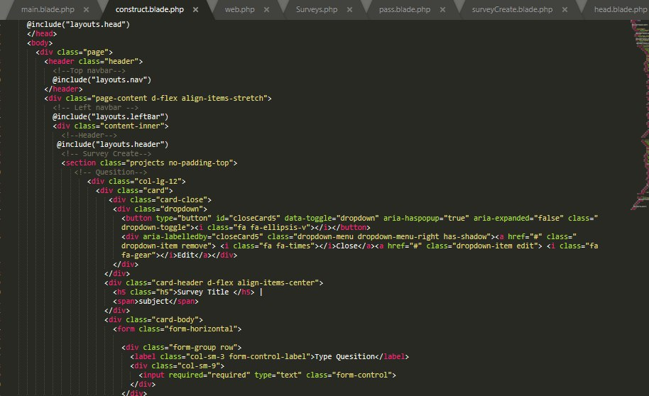

**Migrations:**

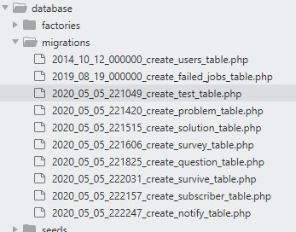

**Model notify:**

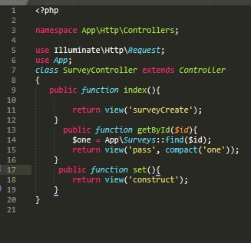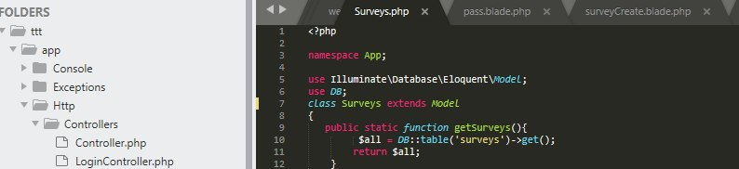

**The Table of our website:**

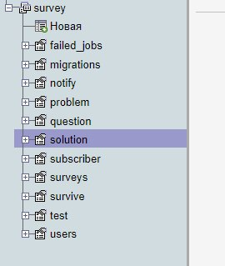

**The user ID`s:**

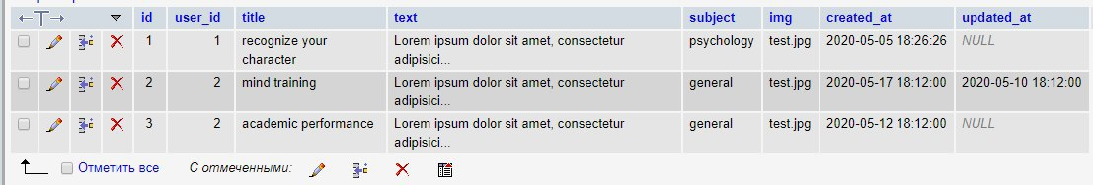

**Summary of each member contribution**

We all together think about the topic of the project and came to one idea over the weeks. During the first week, we made several surveys for our project theme. Initially, we had chosen the Internet magazine project, but we think that this project was obvious for many people and we decided to stop on another topic. The next week, we had chosen topic about online surveys, because we found out from our experience that in quarantine period almost everyone applied for online surveys as we did. However, this topic was also common and we thought to add and update this project to online study and survey project. On a middle of given time, we started to work on source code of online study and survey site.

**What about member contribution?**

**Khaydarov Mirrakhmon (u1810180) and Karimov Otabek (u1810062)** start to create and work on database of our project. Then they pushed it to **Github** **repo.**

**Kuchkarov Utkirbek** **(u1810142)** later work on finishing database and starting the front-end part of the project. Then he pushed them to provided **Github** **repo.**

**Siddikov Khalillokhon (u1810162)** continue adding some back-end features working on PHP, also he pushed them toour **Github repo**.

**Tursunov Shokhrukh (u1810175) and Kuchkarov Utkirbek (1810142)** continue working on back-end and finishing the design of the project, then pushed to our **Github repo**.

**Karimov Otabek (u1810062)** finally finished connecting all above works to one repo and submitted our finished project to provided **Github repository.**

**Different user of our web site and their login and passwords:**

**Login:** [kuchkarovutkirbek@gmail.com](mailto:kuchkarovutkirbek@gmail.com) **password:** qwerty123

**Login:** [khaydarovmirrakhmon@gmail.com](mailto:khaydarovmirrakhmon@gmail.com) **password:** qwerty123

**Login:** [karimovotabek@gmail.com](mailto:karimovotabek@gmail.com) **password:** qwerty123

**Login:** [siddikovkhalillokhon@gmail.com](mailto:siddikovkhalillokhon@gmail.com) **password:** qwerty123

**Login:** [tursunovshokhrukh@gmail.com](mailto:tursunovshokhrukh@gmail.com) **password:** qwerty123